August 18, 2026
Public Health Partners,
It is my greatest pleasure to extend a warm invite to all public health partners to the Southwest OEHA District 2026 Fall Conference. The conference will be held at the Sinclair Community College, David H. Ponitz Center (Building 12), 301 W. Fourth Street, Dayton, Ohio 45402 on Wednesday, October 7th and Thursday, October 8th.
At OEHA, our mission has always been to work on behalf of our members to safeguard Ohio’s health, and to pursue equitable environmental health regulations. We firmly believe in the power of collaboration, education, and innovation to create a healthier and more sustainable future for our communities. This conference will serve as an invaluable platform for networking, learning, and professional growth.
Our program this year has been thoughtfully designed to offer a diverse range of educational sessions and networking opportunities. Both days will provide Registered Environmental Health Specialists with up to 12 CEUs, pending Ohio Department of Health approval. I encourage you to make the most of this conference by actively participating in the sessions, asking questions, and exchanging ideas. The value of this experience lies not only in the knowledge gained, but also in the relationships formed and strengthened.
In this packet, you will find the conference registration and agenda, nomination forms for Outstanding Environmental Health Specialist Award and Membership Recognition Award, information on Picture This, directions, and lodging information.
Every year, we provide a wide variety of raffle prizes and hold a 50/50 drawing, so don’t forget to bring CASH for your chance to win. All of the money raised will be donated to the George Eagle Memorial Scholarship fund. If you would like to donate an item to the raffle, please feel free to contact me, Emily Tyler, at emily.tyler21@outlook.com / emilytyler@us.af.mil.
I would like to express my deepest gratitude to the dedicated members of the OEHA Southwest District Conference Planning Committee and our generous sponsors for their continued support.
If you have any questions or concerns, please do not hesitate to contact me.

Emily Tyler, MPH, REHS
2026 Southwest District Director

Southwest OEHA 2026 Fall Educational Conference
Wednesday – Thursday, October 7–8, 2026
Sinclair Community College, David H. Ponitz Center (Building 12), 301 W. Fourth Street, Dayton, Ohio 45402
REGISTRATION FORM

PLEASE PRINT OR TYPE CLEARLY – NAME BADGES WILL REFLECT REGISTRATION INFORMATION

NAME: REHS or RHESIT NUMBER (if applying for CEUs)

ORGANIZATION

MAILING ADDRESS (where you want to receive your mail) CITY / STATE / ZIP

PHONE EMAIL

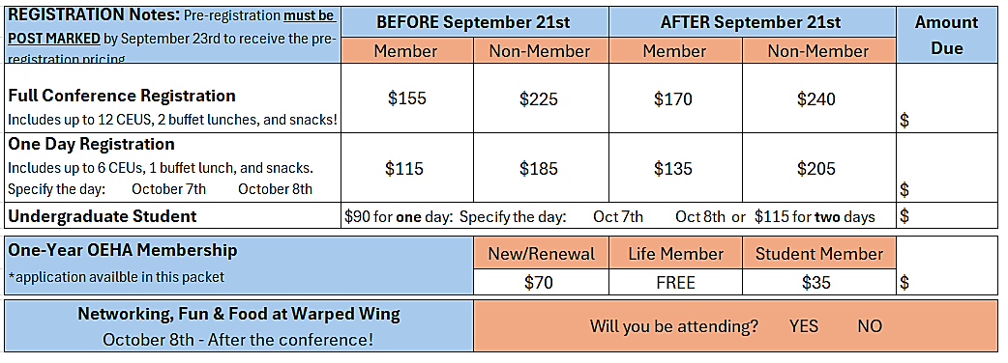

** If you have dietary need, please indicate the need there: _______________________________________________________
PAYMENT METHOD |  |  |  | Send payment to:
Check enclosed |  |  |  | OEHA
Make check payable to 'Ohio Environmental Health Association'. |  |  |  | c/o Alex Dayton
 |  |  |  | 301 South Third Street
Purchase Order |  |  |  | Hamilton, OH 45011
Organizations only; terms 30 days from billing
Submit official purchase order # on an organizational letterhead to alexander.dayton@bcohio.gov and an invoice will be provided. When returned to OEHA, the invoice shall include all names of attendees and the number of days in which they will be attending the conference.
To receive CEUs, payment must be received within 28 days of the conference.
Contact Alex Dayton at alexander.dayton@bcohio.gov or Emily Tyler at emily.tyler21@outlook.com/emily.tyler@us.af.mil with any questions.

**AGENDA IS SUBJECT TO CHANGE

Wednesday, October 7, 2026
Time Session Topic Speaker
7:30–8:15 AM | Registration
8:15–8:30 AM | Welcome & Business Meeting | Emily Tyler, MPH, REHS  Wright-Patterson AFB  SW OEHA District Director
8:30–9:45 AM | General Session:  Leadership | Chris Cook, MPH, REHS,  Clark County Combined Health District
9:45–10:00 AM | Room Change
10:00–11:00 AM | Rodent Management/Sewer Baiting | Jack Tobler, REHS & Beth Bryant, REHS  Cincinnati Health Department
10:00–11:00 AM | Anua Aerocell Plan and Installation – Review for the Regulator | Dustin Kent  ANUA
10:00–11:00 AM | A Holistic Approach to Public Health Lead Investigations: Patient Care Beyond Hazard Control | Jeff Ringiesn,  Public Health-Dayton & Montgomery County
11:00–11:15 AM | Room Change
11:15–12:15 PM | RAPCA Asbestos Program – Inspection Findings and Enforcement Cases | Sarah Sink & Olivia Bartlett  RAPCA
11:15–12:15 PM | Norweco Singulair & Singulair Green ATUs | Brett Wieber  Vice President - Treatment System Sales, Norweco
11:15–12:15 PM | TBD | TBD
12:15–1:15 PM | LUNCH
1:15–2:15 PM | Pool Pump Rooms – What am I Looking At? | Andrew Evans, MPH, REHS,  Public Health Dayton & Montgomery County
1:15–2:15 PM | Top 10 Ways to Lose Money Installing Septic Systems | Brian Martucci  Infiltrator Water Technologies
1:15–2:15 PM | Campground Survey Methodology – Step by Step | Kevin Barlow, RN, REHS  Ohio Department of Health
2:15–2:30 PM | Break
2:30–2:45 PM | President’s Address | Justin Reichard MPH, REHS  OEHA President
2:45–4:00 PM | General Session: VOA Music Festival – Lesson’s Learned | Jim Bolin  Butler County Public Health

**AGENDA IS SUBJECT TO CHANGE

Thursday, October 8, 2026
Time Session Topic Speaker
7:30–8:30 AM | Registration
8:30–9:45 AM | General Session:  Building a Purpose Driven Career in Environmental Health | Steven Ruckman, MPH, REHS  Worthington Schools
9:45–10:00 AM | Room Change
10:00–11:00 AM | Small Egg Producer, Cottage Food, and Home Bakeries | Jason Ahrens, REHS  Ohio Department of Agriculture
10:00–11:00 AM | Working with the Spanish Speaking Community | Ana Rojas, REHS,  Hamiliton County Public Health
10:00–11:00 AM | Water Log Training | Zuzana Bohrer, REHS  Ohio Department of Health
11:00–11:15 AM | Room Change
11:15–12:15 PM | OEHA Membership / SIT  Prep / Leadership | Carrie Yeager, MPH, REHS, Butler County Public Health  Luke Jacobs, MPH, REHS
11:15–12:15 PM | Food Service Operation Employee Health | Hannah Windle, REHS  Ohio Department of Health
11:15–12:15 PM | Tattoos | Bryan Lemons, REHS  Public Health-Dayton & Montgomery County
12:15–1:15 PM | LUNCH
1:15–2:15 PM | Large Water Users | Sarah Hippensteel  Miami Valley Regional Planning Commission
1:15–2:15 PM | The Changing Landscape of Zoonotic and Vector-Borne Disease in Southwest Ohio | Erick Balster, MPH, REHS, RS, CDI, a-IPC  Butler County Public Health
1:15–2:15 PM | TBD | TBD
2:15–2:30 PM | Break
2:30–4:00 PM | General Session:  Drones for Mosquito Surveillance | DJ Shontz, REHS  Greene County Public Health
4:00–4:15 PM | Wrap-Up | Emily Tyler, MPH, REHS  Wright-Patterson AFB  SW OEHA District Director

OHIO ENVIRONMENTAL HEALTH ASSOCIATION
OEHA Southwest Fall Educational Conference Sinclair Community College, David H. Ponitz Center (Building 12)

October 7th & 8th, 2026

Please submit completed nomination forms to:

Hannah Barklay, MPH, REHS
Wright State University
hzbarklay@gmail.com

Outstanding Environmental Health Specialist Award – Southwest District

Your name: Your title:

Your organization information (such as organization name, address, phone, fax, email):

Who you are nominating: His/her title:

His/her organization information (such as organization name, address, phone, fax, email):

Tell us why you are nominating this person for the Outstanding Environmental Health Specialist Award: Attach extra pages if necessary:
_______________________________________________________________________________________________________________________________
_______________________________________________________________________________________________________________________________
_______________________________________________________________________________________________________________________________
_______________________________________________________________________________________________________________________________
_______________________________________________________________________________________________________________________________
_______________________________________________________________________________________________________________________________
_______________________________________________________________________________________________________________________________
_______________________________________________________________________________________________________________________________
_______________________________________________________________________________________________________________________________
_______________________________________________________________________________________________________________________________

OHIO ENVIRONMENTAL HEALTH ASSOCIATION
OEHA Southwest Fall Educational Conference Sinclair Community College, David H. Ponitz Center (Building 12)

October 7th & 8th, 2026

Please submit completed nomination forms to:

Hannah Barklay, MPH, REHS
Wright State University
hzbarklay@gmail.com

Membership Recognition Award – Southwest District

Your name: Your title:

Your organization information (such as organization name, address, phone, fax, email):

Who you are nominating: His/her title:

His/her organization information (such as organization name, address, phone, fax, email):

Tell us why you are nominating this person for the Membership Recognition Award: Attach extra pages if necessary:
_______________________________________________________________________________________________________________________________
_______________________________________________________________________________________________________________________________
_______________________________________________________________________________________________________________________________
_______________________________________________________________________________________________________________________________
_______________________________________________________________________________________________________________________________
_______________________________________________________________________________________________________________________________
_______________________________________________________________________________________________________________________________
_______________________________________________________________________________________________________________________________
_______________________________________________________________________________________________________________________________

📸
PICTURE THIS

Seen something at an inspection that made you stop, stare, and quietly laugh?

We want to see it!

Submit your most memorable inspection photo for the annual “Picture This” featured at the OEHA Southwest District Educational Conference!

Send us photos that make you think:

🕵️ ”No one will believe this!”
😄 “Okay, this is too funny to not share!”
📘 “Now I understand why the food code exists.”
🤔 “Why? Just…why?”

Submission Deadline: September 24,2026
How to submit: Email your photos to
Carrie Yeager @ carrie.yeager@bcohio.gov

Please use professional judgment: Do not include identifiable people, personal information, or information that should not be shared publicly. Submit only photos appropriate for conference display.

Sinclair Community College Ponitz Center, 301 W. Fourth Street, Dayton, Ohio 45402

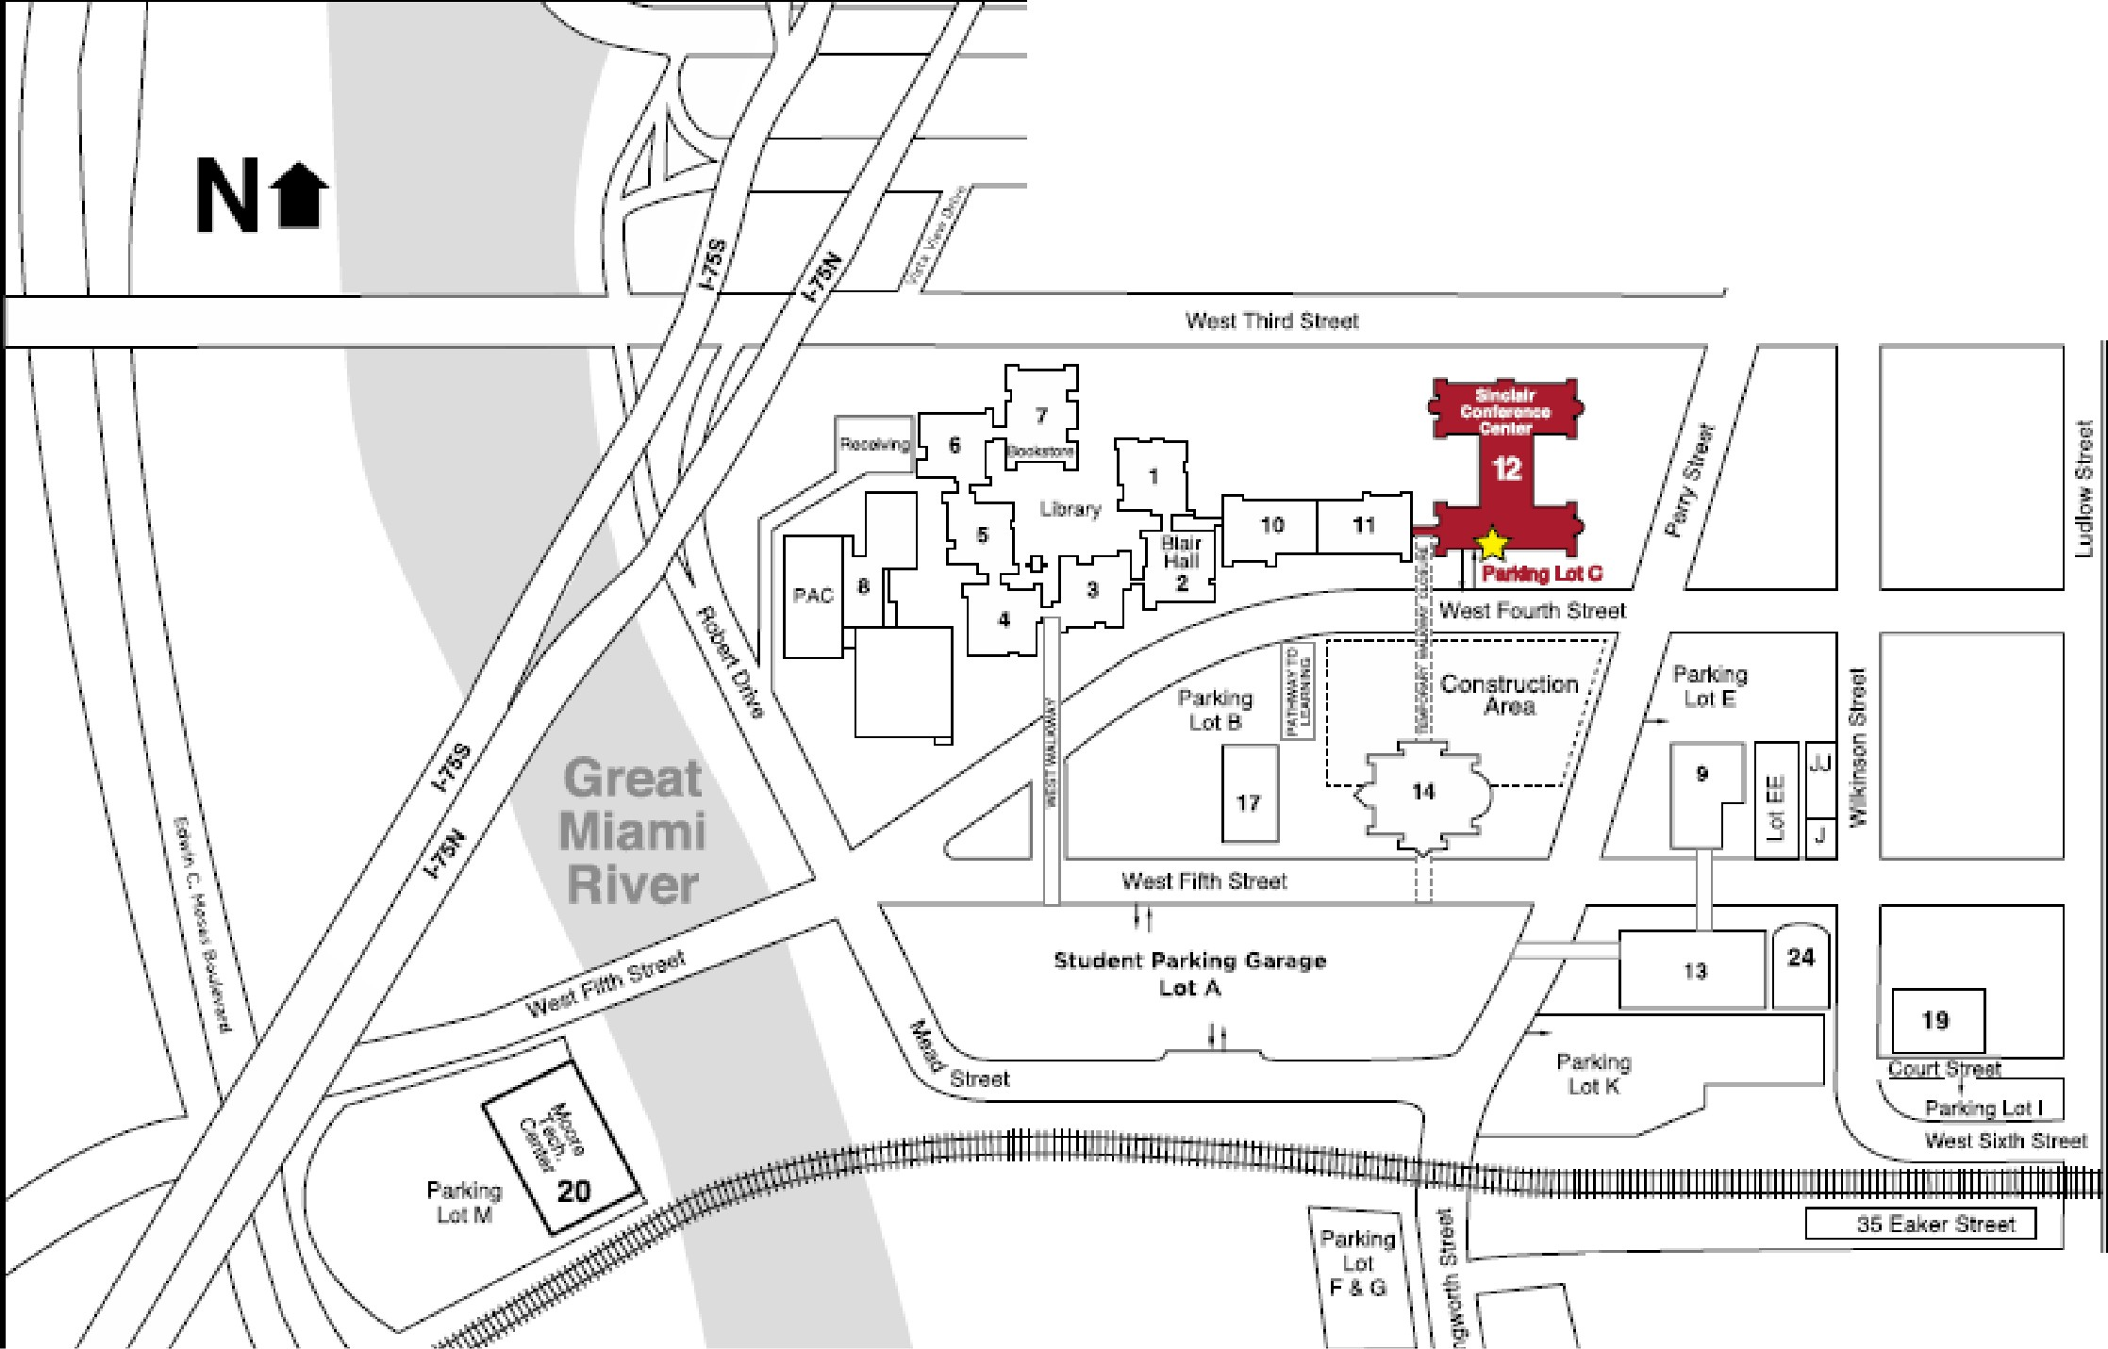

Eal<..,- Street

Lodging Information

Lodging information is provided as a courtesy only and does not constitute an endorsement. Hotel inventory, rates, and amenities can change; call the hotel before booking.

Hotel Address Telephone

Hilton Garden Inn Dayton Downtown 18 W. Third Street, Dayton, OH 45402 (937) 343-1050

Hotel Ardent Dayton Downtown 137 N. Main Street, Dayton, OH 45402 (326) 213-3300

Dayton Vitality Hotel 33 E. Fifth Street, Dayton, OH 45402 (833) 984-1818

AC Hotel Dayton 124 Madison Street, Dayton, OH 45402 (937) 965-7500

Fairfield Inn & Suites Dayton Downtown 305 E. Monument Avenue, Dayton, OH 45402 (937) 331-9330

Marriott at the University of Dayton 1414 S Patterson Blvd, Dayton, OH 45409 (937) 223-1000

Membership Application

Name: REHS/REHSIT#: Title: Home Address: City: __________________
State: Zip: County:

Phone: Email: Employer Name: Address:
City: State: Zip: Work Phone: ____________________
Please send all correspondence to my (check one): Home Address Employer Address Please indicate Membership Type & Dues (check One):

New Member: $70.00 Student Member: $35.00 Life Member: $0.00
Active Member: $70.00 Sustaining Member (Business/Company): $70.00

Please indicate your District by Residence (check one):
Northeast Northwest Southwest Southeast

George Eagle Scholarship Donation: +Dues: =Total: _

Find us online! www.ohioeha.org @OhioEHA
www.facebook.com[OhioEnvironmentalHealthAssociation

