February 21, 2017
Scholarship Committee Report

Members
Joe Ebel, Chair
Dennis Murray
Mark Adams
Jackie Gruza
Kimberly Cupp
The George Eagle Scholarship Committee selects 2 scholarship award recipients each year, one graduate student and one undergrad.
Applications are due by the end of February for consideration by the committee for the awards issued at the AEC.

Sincerely,
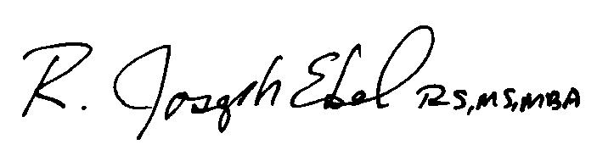
R. Joseph Ebel R.S., M.S.,M.B.A.
OEHA George Eagle Memorial Scholarship
Committee Chairman
(740) 349-6477
www.ohioeha.org
jebel@lickingcohealth.org

